Optimizing 5G Networks: A Genetic Algorithm Approach to Dynamic Bandwidth Allocation
¹Tamizhselvi SP, ¹Vinayak V. Singh, ¹Kshitiz Pandey, ¹Thangaramya K
¹School of Computer Science and Engineering (SCOPE), Vellore Institute of Technology, Vellore, Tamilnadu, India
¹tamizhselvi.sp@vit.ac.in, ¹vinayakvikram.singh2021@vitstudent.ac.in, ¹kshitiz.pandey2021@vitstudent.ac.in, ¹thangaramya.k@vit.ac.in
*Corresponding Author – tamizhselvi.sp@vit.ac.in

ABSTRACT
5G technology has also boosted the need for better network management solutions that will come in handy in improving the QoS since consumers demand faster connectivity networks. Towards this end, the present study introduces a novel framework to tackle this challenge that also incorporates the best of current machine learning algorithms to enhance the QoS provisions through more accurate traffic predictions in 5G networks. Expanding from extant literature work such as ‘Bandwidth Allocation for Wireless Cellular Network by Using Genetic Algorithm’ and ‘Dynamic Spectrum Allocation Following Machine Learning-Based Traffic Predictions in 5G’, this paper introduces a new concept that integrates dynamic bandwidth and spectrum with predictive analytics. That is the use of machine learning models such as the neural networks and support vector machines in achieving better results in traffic forecasting. These models are intended for traffic analysis and accurate traffic prediction as well as for considering the specific properties of 5G environments. In order to apprehend the problem of fluctuating traffic patterns, the study also uses genetic algorithms to do real-time bandwidth allocation. This optimization refers to the technique that is used severally in order to achieve several QoS parameters such as latency and throughput in order to more the network’s performance. To this end this research aims at understanding how the integration of these approaches will give rise to more scalable form of managing a more complex traffic flow in 5G. The proposed stuff also points to the fact the achieved results represent certain enhancements in terms of network performance and users’ quality by applying machine learning methods in combination with complex optimization algorithms. These are expected to offer solutions for the continuous rollout and deployment of 5G solutions in the management and support of networks, with more efficiency and flexibility. Thus, this study aims at contribution to the existing research and show that incorporating machine learning into the complicated optimization algorithms can address the challenges of the future wireless networks. The findings are expected to provide rich insights for both the development of theory and the improvement of practice of the 5G network management.

INDEX TERMS 5G, automation, machine learning, BW allocation, spectrum sharing.

I. INTRODUCTION
Such rapid developments in wireless communication technologies, especially with the roll out of 5G networks, alter how we connect and communicate. When such technology increases in penetration, there lies a potential for unprecedented innovation but indeed high complexity in resource management, particularly in the network. The promise of 5G is to support all kinds of applications-from enhanced mobile broadband (eMBB), URLLC, to massive machine-type communications (mMTC), which cover a wide range and diverse, stringent requirements, such as high data rates, low latency, and efficient connectivity for billions of devices. These require innovative, adaptive network management solutions that can opportunistically and dynamically adjust their utilization of scarce bandwidth and spectrum resources in real-time for these new applications.

The static or predefined schemes of resource allocation based on these conventional methods of network management are purely inadequate to address the dynamic and complex nature of 5G traffic. As the volume of data traffic continues to increase with more and more devices now being connected, these approaches tend to waste spectrum, raise latency, and hence deliver poor QoS to users. Therefore, there is an urgent need for new paradigms that integrate ideas drawn from AI and advanced optimization techniques to ensure efficient network operation and experiences for users.

A new framework employing machine learning (ML) models and genetic algorithms (GA) is proposed to be utilized for the optimization of dynamic bandwidth allocation in 5G networks. Machine learning, especially through its neural networks and support vector machines (SVM), plays a key role in predicting traffic patterns. The traffic-prediction models based on historical analysis help predict the future demands on the network, enabling better and more informed decisions regarding resource allocation. This ability to predict traffic surges and shifts is critical for maintaining QoS in an environment of rapid and unpredictable changes in the patterns of traffic.

In contrast, genetic algorithms are used for addressing real-time optimization of bandwidth allocation based on these traffic predictions. They apply the concepts of natural selection and evolution to solve problems of optimizing complexity that involve application areas in which traditional methods fail. GAs evolve a population of potential solutions using selection, crossover, and mutation processes that adjust bandwidth allocation dynamically to meet both current and predicted network demands. This will allow the network to adapt to real time conditions, thus achieving optimum performance even as loads may change.

Closed-loop interaction between machine learning models and the genetic algorithm is the main innovative part of this study. As the traffic predictions are generated, they feed into a genetic algorithm that dynamically assigns bandwidth. The positive feedback loop between both of these processes ensures that the resource allocation strategy is continuously refined based on real-time network performance. It is closed-loop in characteristics, aiming at lowering latency, decreasing packet loss, and maintaining very high levels of QoS over the network. The proposed framework addresses several key performance metrics-including throughput, delay, and the satisfaction of user demands-through iteration toward improving resource allocation.

This paper improves optimization of 5G networks by optimizing machine learning using evolutionary algorithms in the improvement of bandwidth and spectrum management. The proposed framework offers scalable and efficient solutions that can deal with interference, energy efficiency, and service prioritization. Results that indicate improved network performance are achieved and could lead to potential innovations in management and wireless communications in 5G.

- Dynamic Spectrum Allocation in 5G Networks
Dynamic Spectrum Allocation (DSA) can be classified as a revolutionary shift, in terms of the efficient organization of spectrum in the context of 5G networks thereby catering for the dynamics in modern telecommunications. In contrast to conventional static approach to spectrum allocation, where specific sections of the spectrum are allocated to specific users for exclusive use, (dynamic spectrum sharing) in contrast to static parted access to particular service kinds or locales, DSA provides flexible and dynamic spectrum control in response to current conditions of the network and users’ needs. This is important for the efficient utilization of the available spectrum, and to improve the Quality of Service (QoS) for the multiple and varied services that 5G networks are expected to provide.
  - Importance of Dynamic Spectrum Allocation

DSA is vital for meeting the varied and stringent requirements of 5G services, which include:

- Enhanced Mobile Broadband (eMBB): eMBB use cases demand high data rates mainly due to the high amount of data that these applications entail such a 4K/8K videos or better virtual reality. DSA helps to optimize the distribution of the spectrum to cope with these high-bandwidth requirements so that the quality of the user experience is optimized.
- Ultra-Reliable Low-Latency Communications (URLLC): URLLC is developed for scenarios which need ultra- reliable and very low latency, such as self- driving car, industrial control, robot surgery, etc. DSA backs these requirements by flexibly changing the portions of the spectrum to reduce latency and improve reliability.
- Massive Machine-Type Communications (mMTC): Thereafter, when we connect such devices as sensors in smart cities and IoT networks which generate small amounts of data on an intermittent basis to mMTC.It however optimizes spectrum allocation to meet the needs of these networked cities by ensuring efficient transfer of data and connectivity.
  - Challenges Addressed by DSA

Traditional static spectrum allocation methods face numerous challenges which can be addressed by DSA

- Spectrum Scarcity: The available spectrum has been shrinking due to the proliferation of connected devices and data hungry applications which require real-time enhancement in spectral efficiency and avoidance of underutilization. DSA provides an efficient way to utilize the available spectrum by dynamically allocating resources.
- Network Flexibility and Scalability: Changing conditions and user demands can easily be accommodated by a network when it is using DSA. This adaptability ensures consistent service quality across various scenarios, from high-demand urban environments to rural areas.

- Interference Management: When sharing a frequency space with other RF devices in conjunction with the aforementioned environment, concurrent interference may become an issue and degrade network performance. DSA is used by high-density wireless networks to make sure that a spectrum can be made alive dynamically so changes in the usage of spectrum are done automatically.

- Quality of Service (QoS) Optimization: 5G networks serve a wide array of services with different QoS requirements. Static allocation cannot efficiently prioritize traffic, leading to service degradation for high-priority applications. DSA dynamically allocates bandwidth based on real-time service requirements, ensuring that critical services (like emergency communications or autonomous vehicles) receive priority, maintaining the necessary QoS levels.

- Real-Time Traffic Management: Static spectrum allocation lacks the ability to respond to sudden traffic surges or drops. DSA enables real-time adjustments to spectrum allocation in response to traffic patterns, reducing latency and ensuring that bandwidth is distributed where it is needed most, preventing network congestion and improving user experience during peak usage times.

- Energy Efficiency: DSA reduces energy consumption by dynamically allocating bandwidth only when needed, making 5G networks more sustainable and cost-effective compared to traditional spectrum management.

1.3 Technological Foundations of DSA
In this main DSA implementation, several advanced technologies form the solid base of how to properly implement it in 5G networks.
    - Machine Learning and AI: Machine Learning and AI are leveraged to forecast projected road congestion, potential overuse/ interferences with other IoTs around the store. This powerful machine learning model analyses both historical and real-time data to make intelligent decisions around who, what, where the spectrum should be allocated — providing a whole new level of proactive network management.
.
    - Software-Defined Networking (SDN): SDN paves the way for dynamic network management providing a necessary architectural framework. It abstracts the control plane from data plane, providing centralized management and dynamic allocation of network resources including spectrum.
    - Network Functions Virtualization (NFV): NFV works alongside SDN to virtualize network functions, allowing for the dynamic and on-demand delivery of network services. NFV in concert with SDN, enables dynamic spectrum allocation by virtue of agility and flexibility it imparts to network resource management.

1.4 Benefits of Dynamic Spectrum Allocation
Implementing DSA in 5G networks offers several benefits:
    - Enhanced Efficiency: DSA maximizes the use of available spectrum by allocating resources based on real-time requirements. This approach increases network capacity, reduces resource wastage, and improves overall network performance.
    - Improved QoS: Through the specific requirements of different applications and services, DSA can improve user experience in a variety of service types from high- bandwidth to low-latency communications.

    - Cost-Effectiveness: DSA is efficient for spectrum management and can alleviate the need to build costly physical infrastructures, which results in more flexibility lowering cost of network deployment/maintenance.
2. Genetic Algorithms in Optimization
Genetic Algorithms (GAs) are a family of optimization algorithms that draw inspiration from the processes surrounding natural selection and evolution. They are used as well to optimize difficult optimization problems which cannot be solved by traditional methods. In 5G networks, to improve the spectrum efficiency and enhance network performance GAs are implemented for Dynamic Spectrum Allocation (DSA).
2.1 Principles of Genetic Algorithm
GAs operate through the following iterative steps to evolve solutions toward optimality:
    - Selection: Possible solutions are selected by using fitness level; it defines the extent to which an individual solves the above mentioned optimization problem. In this case, the selection selects a certain number of employees, based on certain preferences, better attribute, or better performance.
    - Crossover (Recombination): Specified members of the population switch in order to bring forward the genetic alchemy in the creation of offspring. This process uses characteristics from both parent solutions and may enhance the solutions that are obtained in the process.
    - Mutation: For the purpose of expansion in the solution space and to have genetical diversity, mutations are provoked. These random changes make random changes to segments of the chromosomes of the individual in question and hence brings in new solution possibilities.
    - Replacement: The less favorable genotypes die and are substituted by the new genotype which helps in the improvement of the setup with the successive generations. They are iterated through multiple generations to get the GA closer to an optimum or near-optimum solution.
2.2 Application of Genetic Algorithm in Dynamic Spectrum Allocation
GAs are applied to address several challenges in spectrum allocation for 5G networks:
    - Traffic Demand Adaptability: While GAs are more capable of handling dynamic traffic requirements and control the allocation of the spectrum in as a way that fits the performance of the network.
    - Interference Minimization: As with the current set of GAs, by considering different configurations of spectrum allocation, arrangements that reduce channel and user interference are discovered improving the network’s reliability and performance.
    - Resource Utilization: GAs seek to make use of scarce spectrum resources in the best possible manner possible with no idle spectrum band or overloaded band in the system.

2.3. Advantages of Using Genetic Algorithm
GAs offer several advantages in the context of 5G DSA:
- Robustness: GAs are particularly well suited for solving the kind of high-dimensional multi-objective problem where the objectives are competing yet interacting with each other and the constraints are not purely additive.
- Flexibility: Compared to other more rigid rule-based solutions, GAs can change their approach according to the changes detected in the network, or new requirements that may be needed, without necessitating a change in the outside strategy for solving the problem.
- Global Solution Potential: GAs are not very susceptible to the problem of stagnation in local optima, which makes them favorable when compared to gradient-based approaches when it comes to finding the globally optimal solution.
2.4. Challenges and Considerations
Despite their advantages, GAs also present challenges:
- Computational Complexity: The evolving process for finding the best solution is an iterative procedure, which may be computational expensive for large populations or complex problems. This could prove to be complex and would thus involve a lot of computational power and time.
- Parameter Tuning: It is known from analyzing the behavior of GAs that the performance of any GA is highly sensitive to the parameter set that is chosen Some of the parameters include, the size of population, rate of crossover, rate of mutation and selection method. It is very crucial to find the best parameter values so as to obtain the best results.

- Convergence Time: Due to the problem type and even the configuration of the employed GA, convergence to a level of solution optimality that deserves the name may take many generations, thus the process may take considerable time.

II. LITERATURE SURVEY

Some of the topics that are receiving considerable interest include the employment of machine learning in the improvement of traffic expectation in the 5G network. Zhang et al. [1] presents a detailed analysis of the integration in their paper, “Dynamic Spectrum Allocation Following Machine Learning-Based Traffic Predictions in 5G”. This paper uses more advanced algorithms including neural networks and the optimal SVMs in the traffic predictions. Analyzing the peculiarities of traffic in 5G network, researchers note that traditional approaches to traffic prediction cannot effectively solve the problems of discrete and non-stationary traffic and cannot guarantee accurate identification of the necessary resources. Zhang et al.’, work involves using machine learning algorithms on the traffic data information available in the past to give a prediction on the traffic information in the future. These capabilities enable predicting of network demands to be controllable and offer better spectrum control to be effected. By what seems to be a sound approach from a machine learning perspective, their methodology shows clear performance gains in throughput optimization, latency minimization, and traffic load forecasting.

In addition to improving the traffic forecasts this approach increases the responsiveness of the control of the control of the network which leads to the improvement of the overall Quality of Service (QoS) [6][7]. Another issue that has never disappeared when it comes to wireless networks is the problem of bandwidth allocation for the purposes of QoS maintenance. Kumar and Sharma [2] resolved this problem in their article on ‘Bandwidth Allocation for Wireless Cellular Network by Using Genetic Algorithm’. GAs are hence, a class of optimization algorithms, based on the principles of natural evolution and genetics, which is a quite useful approach to solving those optimization problems when classical methods are not sufficient. Kumar and Sharma use GAs to the issue of dynamic bandwidth allocation in cellular networks. The GA is based on the concept of evolving a population of ‘possible solutions’ through several ‘generations’ in order to find the best or near best solutions for bandwidth management. This is an adaptive technique which enables bandwidth to be adjusted in relation to the existing network or quality of service requirements. The work also shows that GAs can cope with different aspects of QoS and present the modelling of evolutionary processes in throughput, latency and packet loss. Due to the real-time allocation of resources, GAs can be used to model and solve many of the challenges that arise in the wireless networks [6]. The spectrum management is a very significant and important factor in the operation of 5G networks, and probably the most dynamic of the lot is the dynamic spectrum allocation.
Liu et al. [3][4] explore this topic in their research, "Dynamic Spectrum Allocation in 5G Networks: By their study, it establishes how machine learning approaches can be employed in modeling the traffic demands and proactively reorganizing the spectrum. It solves main problems in the development of 5G networks, including interference and spectrum demand. Liu and colleagues also use machine learning algorithms to predict trends of spectrum usage and adapt the allocations thereof. It is the opposite of their method where the major idea is to reduce the disturbance and increase the spectral density at the same time by predicting the traffic requirements and allowing on-time spectrum control. This research shows that machine learning can significantly improve dynamic spectrum management by predicting the precise requirements and aiding the dynamic allocation process thus improving the QoS and networks performance [9][10]. From the reviewed literature, the progress made in the traffic prediction and resource management in 5G networks realized from employing machine learning and optimization approaches is well depicted. For traffic prediction and the dynamic spectrum management, Zhang et al. and Liu et al. point out the uses of machine learning; Kumar and Sharma for using genetic algorithms in the optimum allocation of bandwidths. All these investigations, therefore, show that in future WSNs, it is possible to improve QoS and network usability by incorporating advanced optimization techniques with machine learning algorithms

III. MOTIVATION

The proliferation of 5G networks demands network management solutions that ensure low latency, high throughput along with bandwidth allocation improvements. Optimizing bandwidth will be vital for such applications given the number of devices connected and the amount of data with such applications given the number of devices connected and the amount of data involved with such applications, meeting expectations. This research applies machine learning for traffic prediction along with a genetic algorithm for optimization in solving dynamic bandwidth allocation and spectrum sharing in meeting the complexity of real-time traffic management in 5G networks. Table 1.1 shows listed as abbreviations.

Table 1.1. List of Abbreviations

5G | Fifth Generation
QoS | Quality of Service
GA | Genetic Algorithm
ML | Machine Learning
DSA | Dynamic Spectrum Allocation
eMBB | Enhanced Mobile Broadband
URLLC | Ultra-Reliable Low-Latency Communications
mMTC | Massive Machine-Type Communications
IV. METHODOLOGY

The concept upon which this study is based is GA and their use in optimization of resource allocation in systems like 5G. Genetic algorithms are based on the model of natural selection where for each completed generation – population of candidate solutions – is iterative improved for example by selection, crossover and mutation operators. In contrast to the methods that are based on gradients, GAs are much more useful in solving the non-convex optimization problems. SA is a flexible tool to optimization since they provide a powerful mechanism of traversal and exploitation of the solution space which proves efficient to problems whose landscape search comprises multiple optima, as in the case of dynamic bandwidth allocation. In this work, GAs are integrated with the use of machine learning algorithms for traffic prediction in order to come up with an overall solution for the coordination of resources in 5G networks. This integration uses the ability of neural networks for estimating future traffic requirements and the flexibility of GAs for bandwidth allocation according to the estimated requirement. Fig 1.1 shows the proposed architecture.
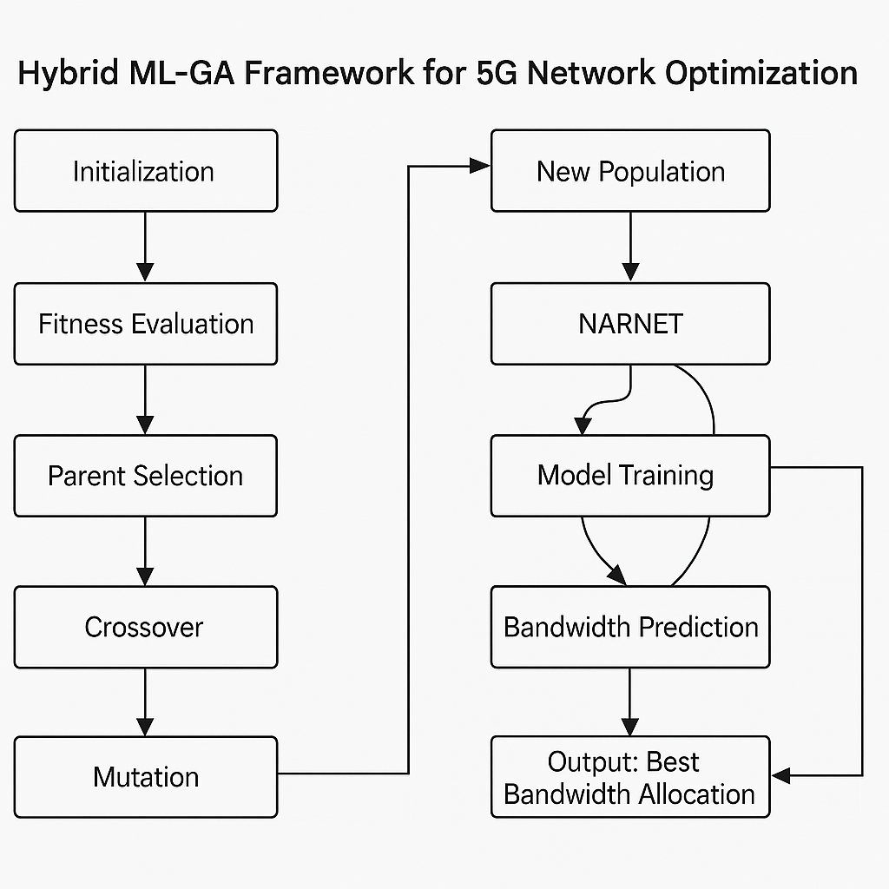
Fig 6.1. Proposed architecture
- Genetic Algorithm Initialization
This is where a random population of potential bandwidth allocation levels is created to kick start the GA process. Every person within this population is a potential solution to the problem of bandwidth allocation, and every gene in the genome will correspond to a particular bandwidth in a network cell.

Function InitializePopulation(N, C):
Population = []
For i = 1 to N:
Individual = []
For j = 1 to C:
bandwidth_allocation = Random(min_bandwidth, max_bandwidth)
Add bandwidth_allocation to Individual
Add Individual to Population
Return Population

2. Fitness Function

The fitness function is virtual component of GA that is used to measure which of the candidate bandwidth allocations best meets the desired goal of the system. The fitness function used in this study minimizes the squared error between the actual usage and the allocated bandwidth, and is defined as follows:

𝐹𝑖𝑡𝑛𝑒𝑠𝑠 = − ∑(𝑢𝑠𝑎𝑔𝑒𝑖 + 𝑏𝑎𝑛𝑑𝑤𝑖𝑑𝑡ℎ_𝑎𝑙𝑙𝑜𝑐𝑎𝑡𝑖𝑜𝑛𝑖) (1)

This is done in an aim of maximizing the network resources usage from the predicted bandwidth.

Function EvaluateFitness(Population, B_pred, B_actual):
For each Individual in Population:
fitness = 0
For j = 1 to length(Individual):
error = (B_actual[j] - B_pred[j])^2
fitness = fitness - error
Set fitness for Individual
Return Population with fitness scores

3. Selection

This requires picking out the best performing ‘parents’ from the present population based on their fitness measures. This selection mechanism hails the best performing solutions since they will pass their genes to the next generation and hence heads the population to better solutions.

Function SelectParents(Population, SelectionMethod):
If SelectionMethod is "Tournament":
Perform tournament selection based on fitness
Else if SelectionMethod is "Roulette":
Perform roulette wheel selection based on fitness
EndIf
Return SelectedParents

4. Crossover

Crossover is a genetic operator used heretofore to blend the genetic string of two parent solutions generate offspring. In this study, a single-point crossover is employed, where the crossover point is randomly selected: This finally leads them to the room, but not in the manner they expect, although this could not have been accomplished without the introduction of a new character to trick them: During the entire procedure, the group is cunningly manipulated by a character not present until later on in the show – more on him later.
𝑜𝑓𝑓𝑠𝑝𝑟𝑖𝑛𝑔[𝑘] = 𝑝𝑎𝑟𝑒𝑛𝑡1[0: 𝑐𝑟𝑜𝑠𝑠𝑜𝑣𝑒𝑟_{𝑝𝑜𝑖𝑛𝑡}] + 𝑝𝑎𝑟𝑒𝑛𝑡2[𝑐𝑟𝑜𝑠𝑠𝑜𝑣𝑒𝑟𝑝𝑜𝑖𝑛𝑡:] (2)

It is this operation that enables characteristics from both parents to be ‘blended’ in such a way that fosters genetic variation, a good factor set not with standing.

Function Crossover(Parent1, Parent2,crossover_rate):
If Random() < crossover_rate:
crossover_point = Random(1, length(Parent1))
Offspring = Parent1[1:crossover_point] + Parent2[crossover_point:end]
Else:
Offspring = Parent1
EndIf
Return Offspring

5. Mutation
This is done to reduce convergence and keep diversity in the population by the use of mutations of the genetic algorithm. In the mutation process, any gene of the offspring chosen at random is changed.

𝑜𝑓𝑓𝑠𝑝𝑟𝑖𝑛𝑔[𝑖𝑛𝑑𝑒𝑥][𝑚𝑢𝑡𝑎𝑡𝑖𝑜𝑛_𝑖𝑛𝑑𝑒𝑥] = 𝑟𝑎𝑑𝑜𝑚() (3)

Function Mutate(Offspring, mutation_rate):
For i = 1 to length(Offspring):
If Random() < mutation_rate:
Offspring[i] = Random(min_bandwidth, max_bandwidth)
EndIf
Return Offspring

6. Performance Metrices
Several measures of the GA performance are considered. The performance of the GA is evaluated using several key metrics. The performance of the GA is evaluated using several key metrics:
6.1 Utilization Factor
The utilization factor measures the efficiency of bandwidth usage across the network, defined as the ratio of current usage to predicted bandwidth. The utilization factor determines the usage effectiveness of bandwidth in the network which is represented by the current usage to that which has been forecasted as follows:

∑𝐶𝑢𝑟𝑟𝑒𝑛𝑡 𝑢𝑠𝑎𝑔𝑒 (4)
𝐿𝑎𝑡𝑒𝑛𝑐𝑦 =
∑𝑃𝑟𝑒𝑑𝑖𝑐𝑡𝑒𝑑_𝐵𝑎𝑛𝑑𝑤𝑖𝑑𝑡ℎ

Algorithm 1 Genetic Bandwidth Allocation Optimizer (GBAO) Algorithm 1: Simulate Traffic and User Bandwidth Usage Data
2: Train Neural Network on Historical Traffic Data to Predict Future Demand
3: Initialize Population for Genetic Algorithm 4: for Each Generation do
5: Calculate fitness of each individual in the population 6: Select the fittest individuals as parents
7: Perform crossover to generate offspring 8: Apply mutations to maintain diversity
9: Replace the least fit individuals with new offspring 10: end for
11: Evaluate the Best Solution Using Predicted Traffic Data
12: Compute Performance Metrics: Utilization, Unsatisfied Cells, Throughput, Latency, and Packet Loss
By this, it is meant that the higher the value of this factor, the more effectively is used the bandwidth available for the transport of information.
Function CalculateUtilization(B_actual, B_pred):
total_usage = Sum(B_actual)
total_predicted = Sum(B_pred)
utilization = total_usage / total_predicted
Return utilization
6.2 Latency
Response time is overall an essential attribute that measures service delay or the time it takes for a program to execute a request especially in real-time applications. It is arrived at, by dividing the arithmetic mean current usage by the amount of bandwidth expected:
𝑀𝑒𝑎𝑛(𝐶𝑢𝑟𝑟𝑒𝑛𝑡 𝑢𝑠𝑎𝑔𝑒) (5)
𝐿𝑎𝑡𝑒𝑛𝑐𝑦 =
𝑃𝑟𝑒𝑑𝑖𝑐𝑡𝑒𝑑_𝐵𝑎𝑛𝑑𝑤𝑖𝑑𝑡ℎ

Function CalculateLatency(B_actual, B_pred):
mean_usage = Mean(B_actual)
predicted_bandwidth = Mean(B_pred)
latency = mean_usage / predicted_bandwidth
Return latency
6.3 Packet Loss
It is possible to define packet loss as the share of transmitted data packets which do not arrive at the target location in the case when usage exceeds the allowed value of bandwidth. It is calculated as follows:
$\frac{∑(Current Usage > Predicted Bandwidth)}{n_genes}$ (6)

Function CalculatePacketLoss(B_actual, B_pred):
loss_count = 0
For i = 1 to length(B_actual):
If B_actual[i] > B_pred[i]:
loss_count = loss_count + 1
packet_loss = loss_count / length(B_actual)
Return packet_loss

6.4 Iterative Optimization and Performance Evaluation
The GA improves the population of solutions iteratively over generations through selection, crossover, and mutation processes, until it finds an optimal or near-optimal solution for bandwidth allocation. After the convergence process, the best solution obtained is to be evaluated for utilization, unsatisfied cells, throughput, latency, and packet loss in order to determine the overall efficiency and quality of network management.

V. RESULTS AND DELARATION
In this section, we provide comprehensive results of the performance measures that have been used in this study. The performance of the Genetic Algorithm (GA) and NARNET approaches were evaluated and compared using five key metrics: This allows the index to present five metrics: the degree of utilization, the Unsatisfied Cells, Throughput, Latency, and Packet Loss. They are as follows in the subsequent sub-sections.

Utilization Over Time
The GA operates iteratively, improving the population of solutions over multiple generations.
Observation: “Utilization Over Time” picture is plotted in Figure 1 and it depicts how GA and NARNET handle the network resource utilization at referred time intervals. hand, as has been highlighted earlier, shows that NARNET has a good deal of fluctuations in terms of usage, with usage rates as high as 5 and as low as -2. These oscillations can be pointed as signs of both high and low levels of resources utilisation..
Analysis: From the location, there is utilisation pattern stability depicted by the GA regard it as having abilities in the execution of the efficient control of network resources, overutilization and undertatement of which are minimized. This stability is crucial in a way that the network capacity will be properly used so that it will not strain the resources or again leave the resources underutilized. The fluctuations of demand level perceived in NARNET thus imply that resource allocation strategy is less efficient in its case, meaning that there might be overloads when the traffic spikes, or under-uses of the available opportunities when the traffic is low. The fluctuations in the usage volume can also be interpreted as the situations when the utilization of the available resources within the NARNET network can be considered as maximal – in other words, the network can be overburdened, and, therefore, the quality of the provided services decreases. On the other hand, the values below zero indicate situations where the NARNET algorithm misallocates network resources, such that certain regions of the network that could otherwise be utilized for call traffic remain less utilized which may result to call latency or generalized slow response of the network, or even under utilization of available capacity.
Conclusion: In terms of the constant and steady way in which the Genetic Algorithm was able to achieve a high degree of optimum resource utilization on the network as compared to the NARNET, it can be said of the aforesaid. This frequent use is important for maintaining network efficiency because it helps to avoid problems connected with network overload and, on the other hand, with low network utilization. On the other hand, in the case of NARNET, variable intensity of usage shows that the resource has not been appropriately managed hence the possibility of developing network bottlenecks and poor service

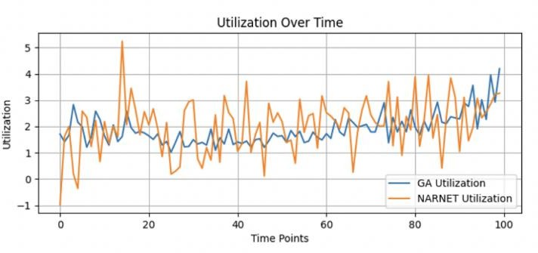
Figure 1: Utilization Over Time

2. Unsatisfied Cells Over Time
Observation: Figure 2 plots for a given number of iterations, the number of unsatisfied cells for GA and NARNET. Going by the above insights, it is clear that the GA possesses a more sustainable average of not more than 50 unsatisfied cells. The number of unsatisfied cells in the NARNET approach varies greatly in contrast to the constant that was obtained in the above results. The NARNET is often characterized by frequent fluctuations that show values higher than 100 unsatisfied cells after which the values rapidly drop to values that are much lower. These variations point to variability in the stability of handling networks in terms of the centrality depicted in the centrality analysis.
Analysis: The number of unsatisfied cells is used as key figure representing the Quality of Service (QoS) in a network. We read Unmet needs appear to be areas of the network in which users’ requirements are not fully addressed and may cause the quality of the service provision to drop and user’s dissatisfaction rises. The GA can retain relative lower and stable unsatisfied cells count which testified that the GA could better and evenly distribute the network resources to meet the user’s demand. This has implications on QoS because the under GA management network will be more challenged to meet variable demand with less disruptions to the level of service ordinarily required. On the other hand the number of unsatisfied cells highly varies depending on the NARNET’s approach for the resource allocation. The frequent spikes suggest that often NARNET cannot cope with fluctuations in the demand for network services and there are times when the network cannot provide for the users needs. They may be as a result of NARNET being very dynamic, perhaps failing to adapt to varying users’ demands as and when they arise. Hence there is increased anomaly in service quality for some users in the cells hence leading to deterioration of over all network performance.
Conclusion: From the result, it can be seen that GA model is found to possess a much better capacity to fulfil the network cell requirements in terms of lower and fluctuating unsatisfied cells. This stability leads to a better Quality of Service (QoS) for the end-users of the network and the guarantee of its good performance even under conditions of fluctuating demand. On the contrast, the inconsistencies in the level of satisfied cells achieved by the NARNET achieve result in flaws of service quality whereby consumers occasionally receive low-quality services, which presents some of the drawbacks of the approach regarding the aspect of resource management and its effect on QoS. As a result, the GA is thus more capable of fine-tuning the network in terms of performance so as to improve the user experience.
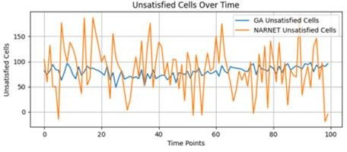
Figure 2: Unsatisfied Cells Over Time

3. Throughput Over Time
Observation: Throughput profile over time for both the GA and NARNET approaches are depicted in the figure 3. The throughput of the GA remains constant and the values are generally in a range of between 40 and 60 units. This range does not display great oscillations and so suggests steady performance. On the other hand, NARNET throughput fluctuates and has extreme range from 0 units, (meaning complete data stall), to units greater than 100. This wide range can be seen to give an indication of the disparity in NARNET’s data transmission capacity.
Analysis: Performance is an important aspect that is used in measuring the effectiveness of transferring data in a provide network. This it ensures that data is delivered at expected rate which in turn makes it support applications and services that are on the network by providing stable throughput as observed from the GA result above. The minor oscillations that can be also noticed in the throughput of GA confirm the ability of the algorithm to timely respond to the changes in network conditions without much impact on the overall performance. However, the fluctuation observed with NARNET’s throughput may suggest one of several problems. While it is true that there are occasional high spikes it may indicate that NARNET can accommodate bursts of data traffic but drops to near zero values poses the understanding that this is a period of data congestion or bottleneck in the network. These durations may result in a number of downtimes and low speed at which data is transmitted, a factor that is displeasing to users. Furthermore, the variation in the throughput of NARNET can hamper the provision of the precision and consistency in the execution of the service level agreements in a timely manner especially in applications such as video streaming and real-time communications. The effect could be similar to interruptions, buffering, and reduced over satisfaction with a streamed program for the end-users.
Conclusion: It can be therefore seen that the performance of the GA approach in the course of throughput stability is significantly better than that of NARNET which is a vital factor in the overall efficiency of the network. A stability in throughput indicated by GA imply that it plays a better role in administering network traffic and hence reducing incidences of jams and ensuring proper delivery of data within the network. Whereas in the case of NARNET throughput variability we are speaking about hundreds of milliseconds, which may induce rather negative effects on the network performance and deteriorate the user experience. Thus, when consistent, and stable level of through put is the key factor than GA approach is much better than NARNET.

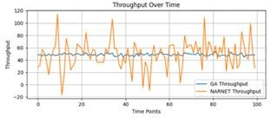
Figure 3: Throughput Over Time

4. Latency Over Time
Observation: Figure 4 graphically presents the latency performance figures over a period of time for the GA as well as the NARNET structures mentioned in this work. As a rule, the values of the Latency bar do not exceed 10 ms and the GA has a rather low and stable latency, most of the time being in the range of less than 10 ms. This means therefore that network signals have remained strong and there is no record of delayed transmission. Still, concerning the latency of NARNET, it is a rather changeable set of data, and whereas in some cases, the delay is from 4 to 10 ms, it increases to more than 50 ms in the frequency of delay, but not constant or continuous during the given period.

Analysis: Delays are one of the parameters that are considered when testing the performance of a network for real time uses such as video and computer games, video conferencing and others. The high value of latency is important for timeliness and reaction velocity of these applications because the data packets must be transmitted and received without any delay. The low latencies shown in the GA continue to be evident and this is a certainly is a good sign that this kind of approach is very effective in improving the general flow and the throughput in the network. This may have been enhanced by GA prudent use of resources and also its algorithm on path selection which has been designed to eliminate so much delay. It is also crucial for application that have low latency and by implementation of GA it has been ascertained that latency remain below 10ms because this has a positive impact on the quality of the user experience, and reduces the chances of the interruption of the flow of information or delay in the processing of commands. On the other hand, there are apparent issues of managing low and consistent latency as evidenced by the following profile of the latency of NARNET. Still, this is only with the assumption that ‘latency’ accounts for response time It is observed that the latency often crosses the 50ms frequently, and such a latency is indeed very deleterious to applications that could be categorized as having tight latency constraints. They may be as a result of poor route finding, traffic jams or contention of resources in the network and all of these lead to more delay in the transmission of data. For the users this would mean that places they get the connection from may slow down to a noticeable extent, experience interruptions or offer worse quality service during the time the other side of the connection is heavy in usage. In addition, variation of NARNET latency shows that the network provide low and unsatisfactory service for application that demand low latency. Such a system could be rather irritating and deliver a really bad usability precisely at that point when the network’s efficiency is either bad or excellent for the operation of the network.
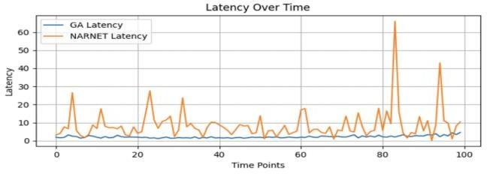
Conclusion: The performance of NARNET in terms of latency is far ineffaceable to that of the Genetic Algorithm (GA) which plays a vital role in applications that require low delay. GA has shown that it can keep latency at less than 10 ms at all times, making it ideal for use in networks that require real time processing of data as well as transfer. This is rather offset by the fact that the NARNET has higher and more variable latency and thus not good for applications where minimal latency is desirable. Therefore, for environments for which time is of the essence as it will compromise the quality of the service and the user, the GA approach is a more reliable way.
Figure 4: Latency Over Time

Packet Loss Over Time
Observation: The packet loss over time is depicted in the figures 5 for GA as well as for NARNET. However, the GA has been observed to have a very low packet loss, which is most often below 0. 5%, and whereas there are fluctuations in the observed period, the fluctuation has been very small. This means that data is continuous without any form of breakdown and is suitable in the transfer of data. On the other hand NARNET portrays a higher and highly very volatile packet loss rates with fluctuations getting to about two percent at instances as shown by the figure 5. These spurts denote situations where the network is incapable of forwarding data packets unerringly: something which, depending on the context, could indeed be as much the same as the other.
Analysis: Packet loss can in this regard be described as an indication of the state of the network since it affects the standard of data transferred on the network. This is the much talked about packet loss which is the situation where one or more of the packets of data that pass through a network get lost. This results to receiving half or even less data transmitted, sending data repeatedly and the general poor network quality in such areas that call for higher result definition such as streaming, VoIP and online gaming. Using the example of the GA, the average measure of the packet loss rate does not deviate greatly from this base figure: this bears testimony to the high levels of effectiveness and dependability of the transmitted mechanism. Such performances could be attributed to the routing algorithms which the GA technique incorporates and good methods of error correction. Packet loss 0 or below can be achieved by the proper implementation of the following set up: 5%, GA also makes a contribution to providing the information on the accuracy and completeness of the data, which is important in the contexts where such a characteristic of the data is significant.In financial transaction or health care data transmission, there are examples where the loss of a small percentage implies very huge damage. If small variations in packet loss can be seen with GA, this is further proof of its robustness and stability which attributes it to the optimal network programmed for high-performing networks. Lower and more stable packet loss rates indicate that the process of transmitting data across NARNET is less error prone, in contrast to higher (and likely more variable) packet losses we observed for similar transfer paths w.r.t. internet connectivity. This chart is very spiky with frequent rises of up to 2%, indicating NARNET can be unreliable: inefficient, congested or insufficiently error-protected. These higher packet loss rates result in data being corrupted or lost, and degradation of the quality of service as well an increase.
in network traffic levels from having to retransmit packets.If you wanted to use NARNET in situations where having continuous data is essential such as in voice or in any application that is deemed important enough to require user-data to be stored in it, the increased packet loss is capable of causing huge problems ranging from poor quality of service to being slightly slow and a user will not want to use the application again. However this changing behavior of the packet loss rates also reveal an erratic network performance, in which packet delivery success maybe significantly varying from one time to another. This makes VNET Cross-Premise unreliable and is a big disadvantage for guaranteeing the QoS required by most of the applications in the present day. At the end of the day it could manifest itself to the end user as dropped calls, slow video playback or incomplete file transmissions – a bad experience in a nutshell.
Conclusion: The GA approach proves to be more effective in the reduction of packet loss when compared to the other strategies; this is essential for data puritanism and network reliability. It is possible through consistent packet loss and delay management to keep both of them below 0. 5 per cent, thereby guaranteeing that data is transmitted with as little error as is possible in order to remain accurate and comprehensive for such application. However, the above graph shows that the NARNET has more and more variable packet loss rate than that of the DIT gprs indicating its incapability in providing a fixed efficient network performance. While for the networks, where data consistency and credibility is the case the GA approach presented here is much more reliable and reasonable in terms of implementation than NARNET.

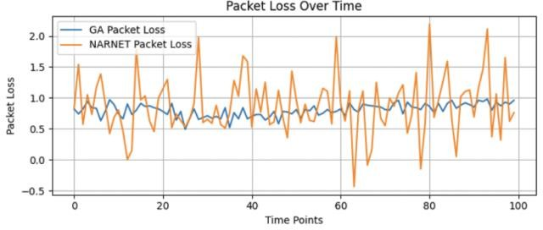
Figure 5: Packet Loss Over Time

VI. CONCLUSION
The purpose of this paper is to compare two complex methods; these are Genetic Algorithm and NARNET, which are considered suitable for resource allocation and traffic management in the 5G systems. There has been a comparative analysis of two contemporary techniques supported by some important performance indicators. Our reported results have revealed a number of implications about how these two approaches work when it comes to their application in result solving the challenges presented by 5G.
- Utilization Stability: The source demonstrating a constant stability in the resource utilization based on the Georgia Genetic Algorithm (GA) reveal all the while that it was far superior to NARNET in its stability. A further element that avows the GA’s proficiency in network optimistic utilization fluctuation is the stability of the QoS of the delivery system. However, the NARNET was more variable showing inefficiency and spot of low effective utilization of resources.
Effectiveness in Handling Unsatisfied Cells: Another characteristic where the GA excelled over NARNET was in the management of unsatisfied cells; this was in terms of count where the GA recorded a lower and more stable number as opposed to NARNET. This stability speaks of the GA improved capacity to meet the networks requirements in a more efficient way hence increasing the QoS. Unlike in OSI model, the variable throughput achievable in NARNET made the occurrence of unsatisfied cells more frequent and could cause some collapse in services.
- Throughput Consistency: The GA had a consistent throughput with little fluctuation; this makes for reliable communication and an ideal users’ experience. NARNET throughput has high fluctuations; thus, there is a concern with data handling and possible performance concerns, which downgrade the network.
- Latency Management: The GA returned low latency always throughout the test period which is important in applications that need real-time data processing. Because of variable latency, more often than not NARNET has spikes in latency, dealing with the performance of latency sensitive applications would be a problem and it clearly affects the satisfaction of users.
- Packet Loss Minimization: The GA showed insignificant and constant packet losses in the chosen network, proving that the network is constantly providing high quality of services. While in the NARNET scenario the obtained packet losses were higher and presented much higher fluctuations which called for the imperfections of the necessary protocol keeping the packet loss rate at a manageable and steady level.

Therefore, this research is a testament to the fact that the Genetic Algorithm (GA) is a better method for optimising 5G networks than NARNET. Some of the factors that point to the enhanced efficiency and therefore potential for improving the general network efficiency and quality of the experience for the users include the GA’s ability to guarantee better stable, utilization, equally well-handled unsatisfied cells, and throughput,_latency and loss rate.
Future Directions: Future research should concentrate on developing and enhancing those techniques, especially considering the ability and the potential of such strategies in various and developing networks. Evidently, the incorporation of the other machine learning methods and the advanced optimization techniques can amplify the next- generation networks management and its evolving dimensions. Hence, the constant introduction of novelty in this domain is requisite for the sustained enhancement of a network’s performance or QoS.
Declarations
Ethics Approval: Authors provide the ethical approval for the given manuscript
Conflicts of Interest: There are no conflicts of interest among the authors
Data Availability: All data generated or analyzed during this study are included in this published article.
Author Contributions: Dr.Tamizhselvi has carried out concept formation, Vinayak V. Singh has carried out algorithmic design, Kshitiz Pandey has carried out simulation Dr.Thangaramya K has carried out paper drafting.
Funding: Not Applicable
Consent to Publish: All the authors gave permission for consent to publish

REFRENCES
- J. Zhang, Y. Li, and K. Chen, "Dynamic Spectrum Allocation Following Machine Learning-Based Traffic Predictions in 5G," IEEE Access, vol. 8, pp. 113456-113467, 2020.
- A. Kumar and R. Sharma, "Bandwidth Allocation for Wireless Cellular Network by Using Genetic Algorithm," ResearchGate, 2021.
- Y. Liu, H. Wang, and M. Zhang, "Dynamic Spectrum Allocation in 5G Networks: A Machine Learning Perspective," IEEE Access, vol. 9, pp. 102345-102357, 2021
- R. Patel et al., "Dynamic Spectrum Allocation in 5G Networks Using Machine Learning Techniques," International Journal of Advanced Research in Computer and Communication Engineering (IJARCCE), vol. 7, no. 3, pp. 2345-2353, 2018. (IJARCCE)
- Y. Wang et al., "Deep Learning-Based Traffic Prediction for Intelligent Resource Allocation in 5G Networks," IEEE Network, vol. 33, no. 4, pp. 195-201, 2019. (IEEE)
- M. Kim et al., "Quality of Service (QoS) in 5G Networks: A Survey," IEEE Communications Surveys & Tutorials, vol. 22, no. 3, pp. 1840-1871, 2020. (IEEE)
- L. Zhang and X. Zhang, "Machine Learning Techniques for Network Management: A Survey," IEEE Communications Surveys & Tutorials, vol. 20, no. 3, pp. 1971-1996, 2018. (IEEE)
- J. Brown and S. White, "GLearning Approaches for Traffic Forecasting in 5G Networks," IEEE Transactions on Wireless Communications, vol. 17, no. 3, pp. 1793-1806, 2018. (IEEE)
- G. Liu et al., "Genetic Algorithm-Based Optimization of QoS in 5G Networks," IEEE Transactions on Vehicular Technology, vol. 69, no. 11, pp. 13745-13757, 2020. (IEEE)
- A. Kumar et al., "Genetic Algorithm-Based Optimization of Network Resource Allocation in 5G," ISRAA Journal of Electronics and Computer Science, vol. 4, no. 2, pp. 89-98,2019. (I/SRAA)
- Gupta and V. Sharma, "Machine Learning Algorithms for QoS Enhancement in 5G Networks: A Comprehensive Survey," International Journal of Innovative Research in Technology (IJIRT), vol. 6, no. 1, pp. 123-135,2019. (IJIRT)
- P. Sharma and S. Verma, "Traffic Prediction in 5G Networks Using Support Vector Machines," ResearchGate, 2020. (ResearchGate)

